TYPES OF RTOS
The Real Time Operating Systems are classified based on the type of deadlines in the completion of execution of the tasks.
Hard Real Time Operating System: Meeting deadline is compulsory, used in multitasking to schedule the tasks within deadline.
Ex: - VxWorks, LynxOS, WINDOWS CE, ThreadX, TinyOS etc.
Soft Real Time Operating System: Meeting deadline is not compulsory, but there should not be failures.
Ex: - QNX
Firm Real Time Operating System: Meeting deadline is not compulsory and there will be chances of some failures but it will not effect the system functionality.
Ex: - QNX, FreeRTOS etc
If the system deadline is absolute then it is called Hard Real Time System and the RTOS used in scheduling the tasks in these kinds of systems are called Hard Real Time Operating System.
Ex: - Traffic Collision Avoidance Systems used in Avionics and Automobiles, RTOS used is VxWorks and LynxOS.
If the system deadline is relaxed then the system is called Soft Real Time System.
Ex: - Multimedia Transmission, Telecommunication for these kinds of systems not necessary to meet the deadline there will be chances of time elapse.
Ex: - Windows 7, OS used in mobiles like Android, IOS etc.
Some RTOS can be configured to meet Hard Deadline, Soft Deadline and Firm deadline based on the type of Real Time System.
Ex: VxWorks

SERVICES OF RTOS
The most important part of the operating system is the Kernel. To monitor the hardware the task should be relieved and the responsibilities kernel manages & allocate the resources. If the task can’t obtain the CPU attention for every time, then there are some other services provide by the kernel. The following are
Time services
Interrupt handling services
Device management services
Memory management services
Input-output services

FEATURES OF RTOS
Occupy very less memory.
Consume fewer resources.
Response times are highly predictable.
Unpredictable environment.
The Kernel saves the state of the interrupted task and then determines which task it should run next.
The Kernel restores the state of the task and passes control of the CPU for that task.

SCHEDULING AND ITS TYPES
Scheduling is the process of deciding which task should be executed at any point in time based on a predefined algorithm. The logic for the scheduling is implemented in a functional unit called the scheduler. The scheduling process is not present only in RTOS, it can be found in one form or another even in simple “bare-bone” applications.
A real-time scheduling System is composed of the scheduler, clock and the processing hardware elements. In a real-time system, a process or task has schedulability; tasks are accepted by a real-time system and completed as specified by the task deadline depending on the characteristic of the scheduling algorithm.

Types of Scheduling Algorithms:
There are many scheduling algorithms that can be used for scheduling task execution on a CPU. They can be classified into two main types:
1.Preemptive scheduling algorithms
2.Non-preemptive scheduling algorithms.

1.Preemptive scheduling algorithms.
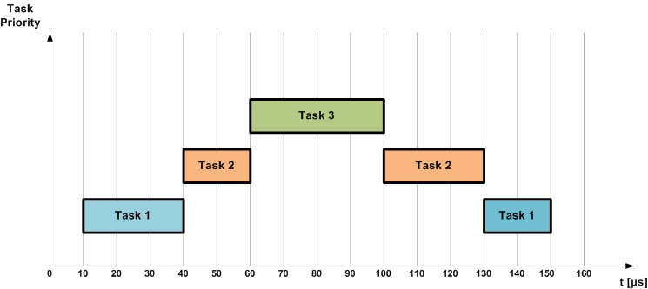

2.Non-preemptive scheduling algorithms.
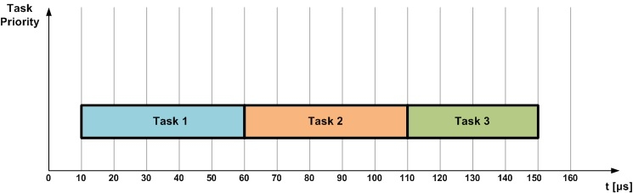

Popular Scheduling Algorithms
Some of the most popular scheduling algorithms that are used in CPU scheduling. Not all of them are suitable for use in real-time embedded systems. Currently, the most used algorithms in practical RTOS are non-preemptive scheduling, round-robin scheduling, and preemptive priority scheduling.

First Come, First Served (FCFS)

Shortest Job First (SJF)

Priority Scheduling

Round-Robin Scheduling

